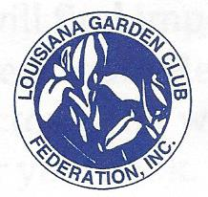
LGCF Awards Application (revised January 2020) Date________________ Award #_______ Award Name ___________________________________________ District _______ Submitted by (name of club): ___________________________Number of members in club: _______
Size of Club (I, ii, iii, iv)______________
(Enter name exactly as it should appear on any award received)
Contact information (club member name and email address) _________________________________

Application is limited to three printed pages, front of pages only. USE THIS PAGE AS A COVER SHEET ONLY with no further information. You may then add a total of three additional pages. No report cover, binders, plastic sheets allowed.
Please complete each topic, if applicable. Use numbering as below when completing form.
1. New project: Yes ____ No ____ Beginning date: _______________________ Completion date: __________________ 2. Brief summary and objectives of project
3. Involvement of club members, other organizations, etc.:
4. Project expenses and means of funding:
5. Continuing involvement, follow-up, maintenance:
6. Attach or insert photos, digital photos, and/or landscape plan (does not need to be professionally drawn).

AWARD APPLICATION SUGGESTION:
1) PRINT FORM
2) Complete form and use as a cover sheet only. ANSWER QUESTIONS 2 THRU 6 using the fronts of three additional pages for a total of four pages.
3) Mail to proper awards chairman found in ﻿General Rules & List of Awards.﻿

