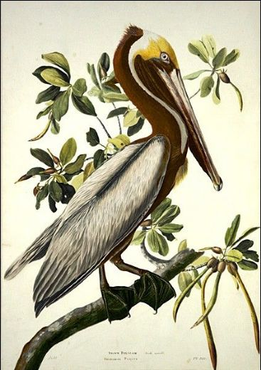
District VIII Meeting

Tuesday, October 15, 2019

Old Lecompte High School

2204 St. Charles Ave.

Coffee 9:30 AM…………time to bid on silent auction items
Meeting 10:15 AM………....program/museum tour
Lunch 12:00 AM…………followed by silent auction winners

$20 per person
Your received check is your reservation! Please make out check out to LGCF District 8 and mail by Oct. 1 to:
Sara Fuhrer
PO Box 55
Lecompte, LA 71346

Questions to Sara Fuhrer, VP, Lecompte Garden Club at 985-237-9848

Name__________________________________________________________________

Address_________________________________________________________________________

Garden Club_____________________________________________________________________

Status: Garden Club, Position (member/officer) ____________________________

