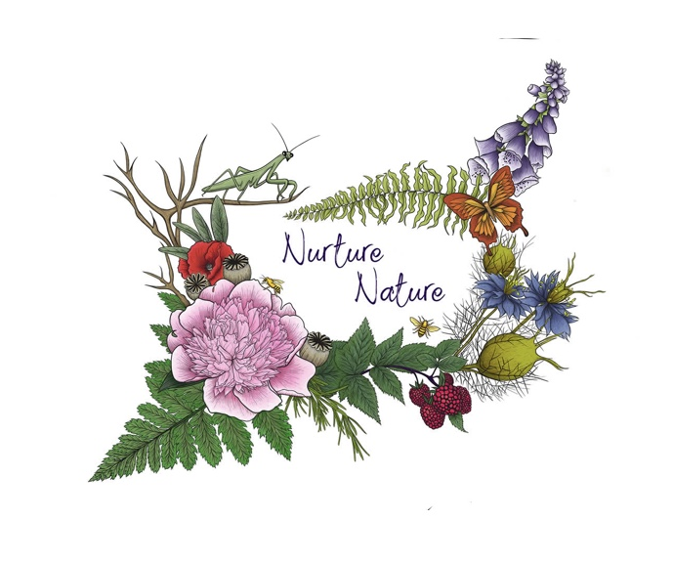
Louisiana Garden Club Federation, Inc.
DISTRICT V GARDEN CLUBS
and
District V Director, Julia Gilmore
Cordially invite you to attend
DISTRICT V FALL MEETING AND LUNCHEON WEDNESDAY, OCTOBER 16, 2019

Delta Community College
2889 Highway 15
Winnsboro, LA 71295

Program: Designing with Nature

Registration 9:30 AM Meeting 10:00 AM
Registration/Lunch $30 Registration Deadline October 4, 2019
Parade of Prizes, Door Prizes, Book Sale
Registration Form Available Online
Mail Registration to:
Caroline Christman
121 Cedar Lane
Delhi, LA 71232
Hotel Information: Americas Best Value Inn
(318) 435-2000

Menu
Stuffed Bacon Wrapped Fish
Cranberry Pecan Rice Pilaf
Green Bean Bundles
Yeast Rolls
Buttermilk Pecan Pie
Tea, Water and Coffee

Reservation Form
LGCF District V Fall Meeting and Luncheon
Wednesday, October 16, 2019
Delta Community College
2889 Highway 15
Winnsboro, LA 71295

Name________________________________________________________________________________
Address______________________________________________________________________________
City______________________________ State________________________ Zip____________________
Phone___________________________ Garden Club____________________________ District______
E-mail______________________________________________
Please CIRCLE THOSE THAT APPLY
LGCF: Officer (Includes District Directors & Representatives-at-Large) Chairman (or alternate)
Former LGCF President LGCF Life Member Club President (or alternate)
Delegate (Clubs with 50 or more members) Club Member Guest
Deep South: Officer State President Chairman DS Life Member
NGC: Officer State President Chairman NGC Life Member
------------------------------------------------------------------------------------------------------------------------------------------
PROGRAM: Designing With Nature
Reservation and Lunch--$30 REGISTRATION DEADLINE OCTOBER 4, 2019
PLEASE MAKE CHECKS PAYABLE TO: LGCF DISTRICT V
Registration Form Available Online
Mail Registration to:
Caroline Christman
121 Cedar Lane
Delhi, LA 71232
Hotel Information: Americas Best Value Inn
(318) 435-2000

