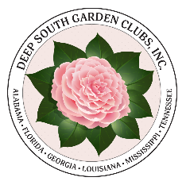
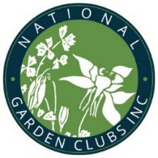
DEEP SOUTH and NGC Award
Application Cover Sheet
2023-2025

NGC Award Number
PDF Version: Complete this form online and then save your completed application. Email your completed application to the DSGC Awards Chair, Roxanna Champagne, roxannachamp@cox.net
(337) 298-5099.

NGC Award Name

DSR Award #
DSR Award Name

State Award #
State Award Name

Name of Group/Club/Individual Applying for Award

If club, number of members
Award Size Group S
M L

If state, number of clubs
Award Size Group
S M L

Contact Name
Email Phone
Address

City ST Zip
Region State

State Awards Chairman
Email Phone
Address

City ST Zip

Is this project New OR Continuing from previous work?
Beginning date Expected completion date OR Ongoing

ATTACH your completed application. Unless noted in specific award description, all applications are limited to three (3) single-sided pages (plus, this cover sheet.) No report covers, notebooks, etc. allowed.

Follow descriptors on Scoring Sheet to prepare an accurate, complete report.
All applications are to be submitted electronically unless otherwise noted in award description.

Send to your State Awards Chairman by the requested due date. Only awards submitted through State Chairmen will be accepted.

