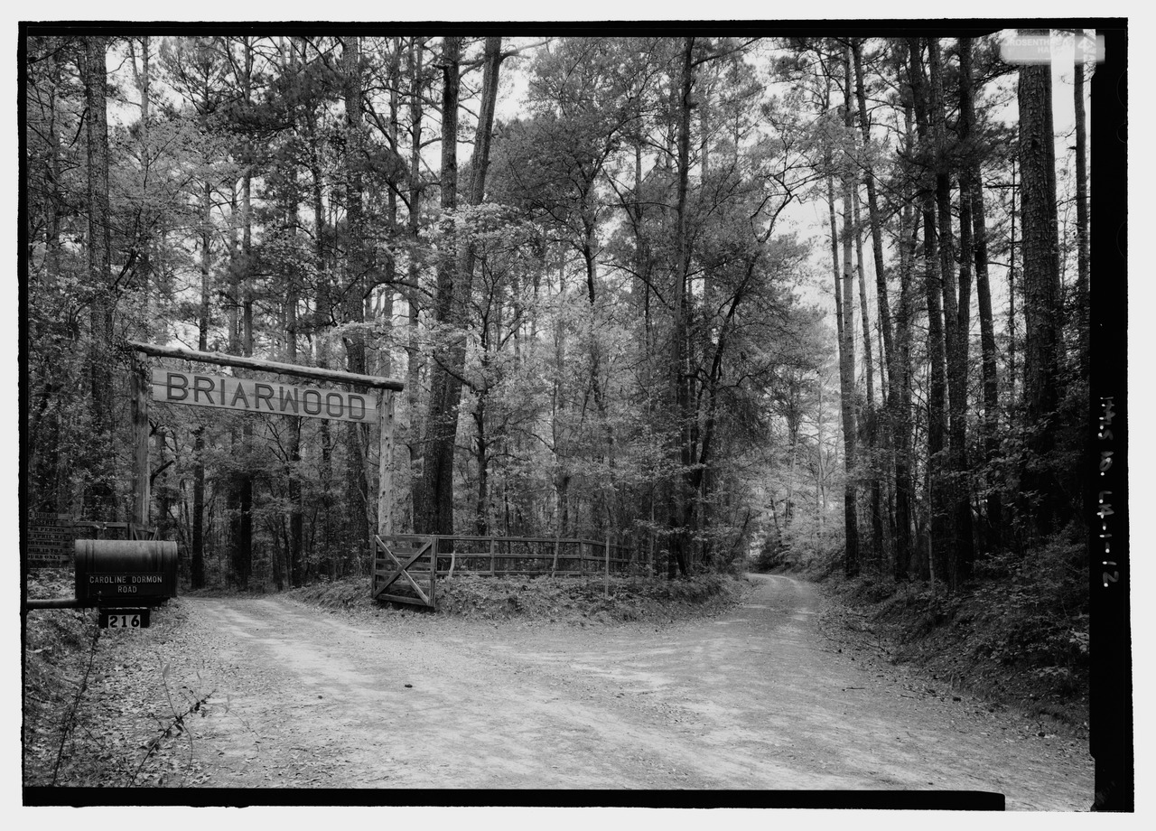
District 8 Clubs
Invites you to join them Tuesday
October 16, 2018 for the District Fall Meeting
To be held at the Pineville Community Center
700 Main Street, Pineville, La.

Coffee 9:30 AM – Time to bid on Silent Auction Items

Meeting 10:30 AM

Lunch 12:00 PM –followed by:

Dr. Jim Barnett, Retired Chief Silviculturist and Emeritus Scientist,
US Forest Service, Southern Research Station
Reviewing his book:
CAROLINE DORMON
“The South’s Exceptional Forest Conservationist and Naturalist”

Res: by October 10, 2018
Cost $30.00
Make checks payable to LGCF District 8
Diane Lawton
324 Holiday Circle
Pineville, La. 71360

Name: _________________________________________________

Address: _______________________________________________

Garden Club: ___________________________________________
Status LGCF, District, Club Position (Member, Officer, etc.)
Any special dietary needs contact: Fran Anderson-318-487-1654

