INVITATION
District III 2018 Fall Meeting
and
Murder on Main Street
Please join host Azalea Garden Club for our fall meeting and a Mysterious time.
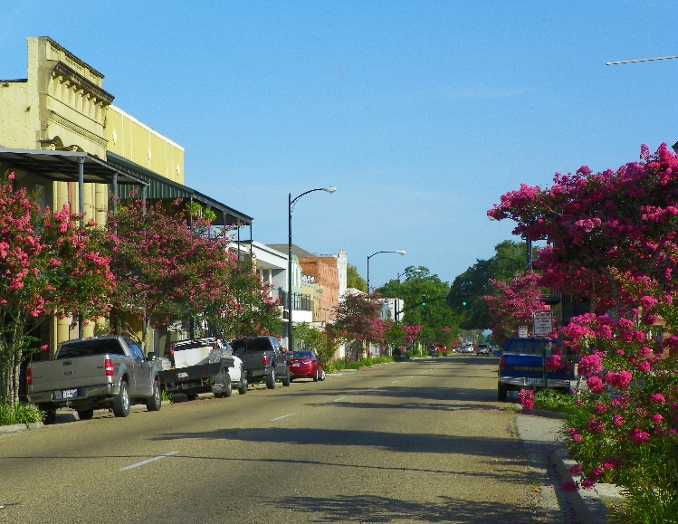

Help us solve the murders that are being committed along Main Street. It could happen in your town!

Thursday, October 25, 2018 Ramada Inn 2915 Highway 14
New Iberia, LA 70560
Registration: 9-10:15 Meeting 10:15-2pm Noon luncheon Buffet
cost $30 per person
Additional information and registration form can be found on LGCF web site

