The Bulb and Blossom Garden Club of Eunice
Cordially Invites you to our
LGCF District VII Fall Meeting and Luncheon
“The Garden Pollinators”
Thursday, October 18th, 2018
Knights of Columbus Hall
300 N. 2nd Street
Eunice, La 70535
Registration: 9:00 A.M. Meeting: 10:00 A.M.

Cost $30.00 per person
Please register by Friday, October 10th
Registration Contact: Barbara Wells (337-546-1225)
1691 Tiger Lane, Eunice, La 70535

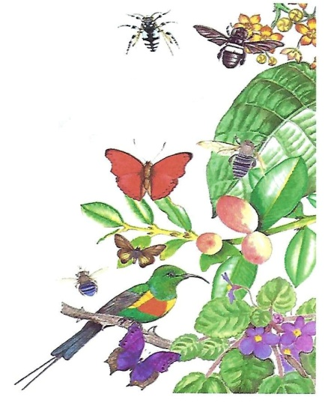
Guest Speaker: Warren Hoagh, Vice President of “Bayou Bee Keepers”

