NAME

CHOICES:

2019 LGCF CONVENTION TRI-REFRESHER

CAFE JEFFERSON
Lunch Menu

April 1, 2019

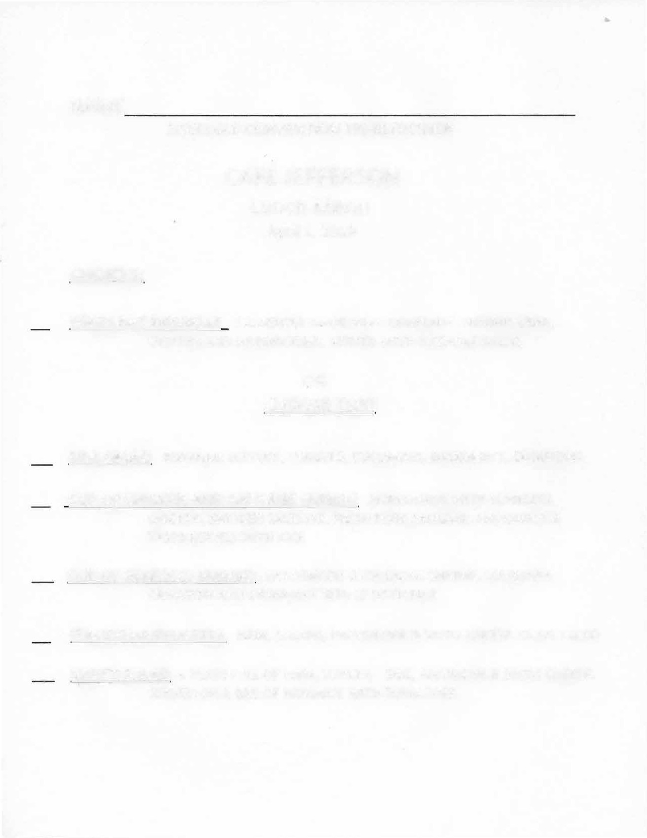
EGGPLANT MICHELLE CASSEROLE MADE WITH EGGPLANT, SHRIMP, CRAB, OYSTERS AND MUSHROOMS SERVED WITH A CEASAR SALAD

OR CHOOSE TWO

SIDE SALAD ROMAINE LETTUCE, TOMATO, CUCUMBER, BACON BITS, CROUTONS

CUP OF CHICKEN AND SAUSAGE GUMBO HOMEMADE WITH BONELESS CHICKEN, SMOKED SAUSAGE, FRESH PORK SAUSAGE, ANDOUILLE & TASSO SERVED WITH RICE

CUP OF SEAFOOD GUMBO HOMEMADE WITH LARGE SHRIMP, LOUISIANA CRAWFISH AND CRABMEAT SERVED WITH RICE

ITALIAN MUFFULETTA HAM, SALAMI, PROVOLONE & SWISS CHEESE, OLIVE SALAD
CHEF'S SALAD A PLATE FULL OF HAM, TURKEY, EGG, AMERICAN & SWISS CHEESE, SERVED ON A BED OF ROMAINE WITH TOMATOES

PLEASE MAKE SELECTION(S) AND INCLUDE WITH TRI-REFRESHER REGISTRATION

