Registration Form District III Fall Meeting

MURDER on Main Street
Azalea Garden Club

Thursday October 25, 2018 Ramada Inn 2915 Highway 14 New Iberia, La 70560

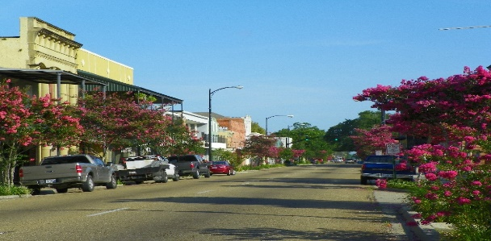

Registration and lunch cost $30.00 per person Registration deadline by Oct. 12, 2018

Name ___________________________________________________________________________
Address __________________________________________________________________________
Phone _____________________ Email: _______________________________________________
Garden Club ______________________________________________________________________

Please Circle Those That Apply

Local Club | Member | Club President | Delegate/Alternate | Guest
LGCF, INC | Officer | Chairman | Life Member | Past President
Deep South | Officer | Chairman | Life Member | Past DSF President
NCC | Officer | Chairman | Life Member | Past NCC President

Please send completed registration forms and one check from your club made payable to Azalea Garden Club to Betty LeBlanc, 215 Country Club Drive, New Iberia, LA 70563. Questions? Contact Betty Leblanc at email: betleblanc@bellsouth.net 337-364-9666 or Millie Comeaux: butterfly539023@bellsouth.net 337-519-2555

