MURDER on Main Street
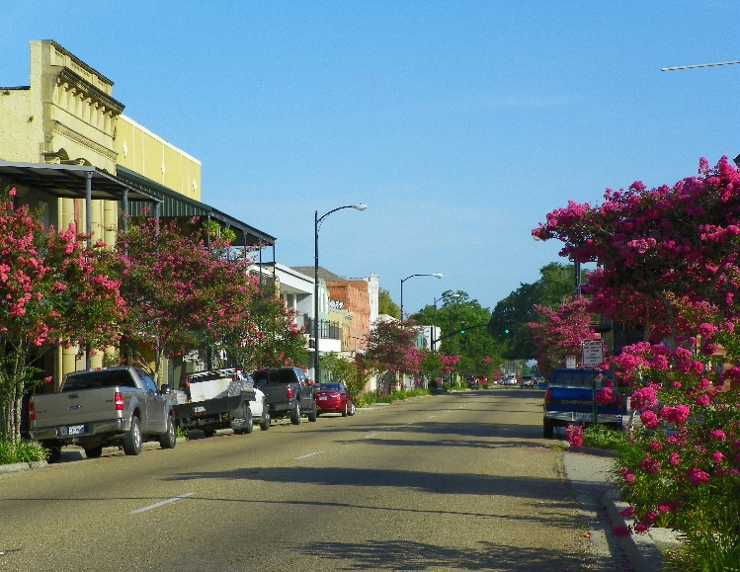
Information for District III Fall Meeting

Hosted by Azalea Garden Club

Thursday, October 25, 2018 Ramada Inn
Exit 14 off Hwy 90 2915 Highway 14 New Iberia 70560

$30 per person for meeting and lunch
Registration 9:00-10:15 (coffee and pastries) Meeting 10:15-2:00
Program: Murder mystery play presented by Azalea Garden Club members

Luncheon Buffet Menu
Mixed green salad
Roast Beef/gravy, Lemon Pepper Baked Fish
Green Beans, sautéed Squash & Zucchini, Carrot Souffle
Garlic Mashed Potatoes
Bread Pudding w/Praline Sauce
German Chocolate Cake
Apple Cobbler
Iced Tea or Water

