2019 LGCF Convention

Parade of Prizes Silent Auction

The Parade of Prizes is another avenue for District III to raise necessary funds to host a successful LGCF Convention. The rising costs of hosting a convention is a challenge. Being open-minded to new and creative methods of raising money has led us to try the idea of a holding a Silent Auction at the convention.

Some of the Auction items include:
An Overnight Stay at the Doubletree in Lafayette, LA; Beautiful Jewelry such as a bracelet from A-Bryan and a pearl bracelet donated by Dee Nolan; a Footed Crystal Bowl; an Iron Wine Stand; Framed Pictures and other Home Decorative Items; Plant Stands; Garden Accent Pieces; Plants, of course; Pottery and Gift Baskets.

During the LGCF Convention these and other items will be available to bid on thru noon on Wednesday, April 3rd. Winners will be announced at at the end of lunch.

Proceeds of this auction will go toward the expenses of hosting the April 2019 Convention in Lafayette.

Anita Petitjean
2019 Convention Parade of Prizes Chair

Drawing
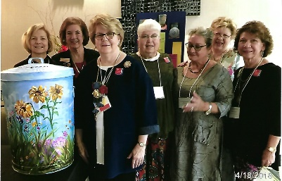
You will be able to participate in the various drawings at the convention. They include a week stay in a 3 bedroom/2bath condo in in the exclusive Los Suenos resort in Costa Rica, a quilt made by garden club member, Sarah LeBlanc, and a beautifully painted trash can perfect for your home or garden.

District III members with NGC President, Nancy Hargroves

