Breakout Speakers 2019 LGCF Convention
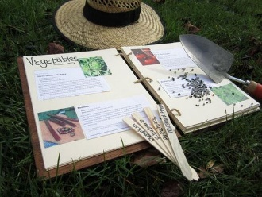
Anita Petitjean In the Garden of My Dreams

In this hands-on workshop, learn how to enjoy creating a garden journal or adapt new ideas to existing journals. Participants will be provided with suggestions, formats, handouts, and other resources for building a successful journal.

Anita learned her appreciation of anything flowers from her mother, aunt, and “adopted grandparents.”
She is a member of the Lafayette Garden Club, Lafayette Parish Master Gardeners, the Louisiana Society for Horticulture Research and the Louisiana Native Plant Society.

B.J. Abshire Real Good Roses

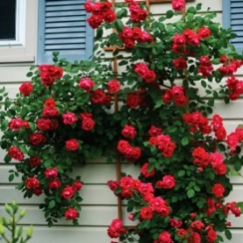
Roses are America’s Floral Emblem and make your garden more beautiful. Learn what varieties of roses are “real easy” to grow plus some that are a little more challenging with a higher level of care. Enjoy lots of pictures of proven rose varieties that will make you successful at growing roses.
B.J. has been a member of the Acadiana Rose Society for 14 years and the editor of the newsletter for almost 12 years. She has been the Society President and Vice President of Programs. She is a Consulting Rosarian, Horticulture Judge and Arrangement Judge for the American Rose Society. B.J. has been growing roses for 20 years. She was fortunate enough to be a stay at home mom and raise her 2 daughters. She found it very satisfying to grow roses, have a vegetable garden at times, feed the backyard birds and just hang out in her yard. The better part of her life was 30 years in Girl Scouts as troop leader and outdoor trainer. She loves being with her 4 grandchildren, growing roses and traveling with her rose friends.

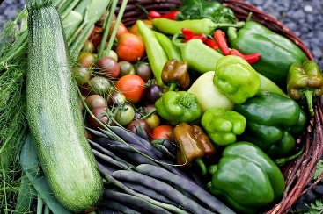
Louann McClelland-Long Saving Heirloom Vegetable Seeds

Seed saving can be a rewarding and cost saving way to garden. It is essential for preserving the diverse and treasured varieties of the past. Learn techniques to save heirloom seeds and to preserve the integrity of your seed stock.

Louann has been a Lafayette Parish Master Gardener since 2009, and an Advanced Louisiana Master Gardener since 2017. Growing up in San Diego, California, Louann became interested in plants native to Southern California and Mexico. While collecting pepper, melon and tomato seeds from area gardeners and farmers, Louann enjoyed hearing the stories of where these seeds came from. The importance of the history behind the seeds developed into an interest in historical farming and heirloom gardening, which has developed into a life-long passion for growing heirloom plants and saving heirloom seeds.

Tina Jumonville Succulents: Tips for successfully growing and propagating these unique plants

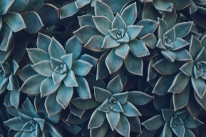
This presentation will help you understand some of the main groups of succulents and the unique care that each of these groups require. We will discuss general pests and problems, and ways to keep them healthy. How to propagate babies will also be discussed, closing with a Q&A session.

Tina Jumonville has been gardening for over 35 years. She is a Licensed Louisiana Landscape Horticulturist and a certified professional for the Louisiana Nursery and Landscape Association. She is a small commercial back yard grower and her company, ‘Tina’s Plants’, has been selling plants since 2012. Tina volunteers as an Advanced Master Gardener through the LSU AgCenter, and is a retired high school Biology Teacher that loves to share horticulture information to help everyone be successful in their own gardening pursuits. She also has a Vendor booth here should you want to purchase a succulent or two to take home.

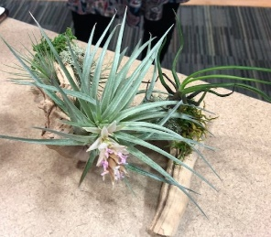
Sandra Creswell Botanical Art Presentation
Sandra will demonstrate techniques to mount epiphytic bromeliads to driftwood. These pieces of botanical art can be used indoors or outdoors. They make excellent gifts and can be a unique addition to the walls in your home or office! Their ability to grow in shade and without soil is one of their main attractions and growing them mounted is a great way to show off this quality.

Sandra is a member of the Abbeville Garden Club and is a Lafayette Parish Master Gardener. She is very active in projects to beautify the city of Abbeville. Sandra has been a gardener for 48 years. She was an advertising executive for 30 years.

Andy Chidester Let’s Learn to Thrill, Fill and Spill – Give your Containers a WOW Factor.
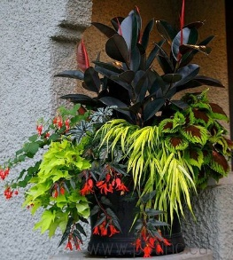
- Most importantly learn why the appropriate and soil and fertilizer are the beginning of great containers
- Choose containers that will help make the statement you don’t have to use just a pot…
- Learn how to pick and group plants to make your containers really POP – great combinations of annuals, herbs, veggies and perennials.
- Learn how to group and place containers on your patio and in your gardens
Andy Chidester is a sales representative for FoxFarm Soil and Fertilizer Company, she has worked in the horticultural industry since 1998. Andy has an Associates in Science. She developed her passion for gardening at a very young age making mud pies by her beloved grandmother’s side in the garden.
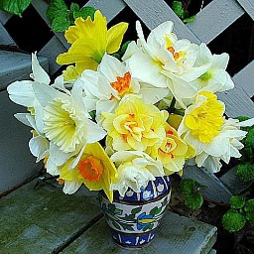
Annette Parker Daffodils and Crinum for the Deep South

The National Garden Club Federation, Inc’s theme is Plant America. The organization’s fundraiser, Bloomin' Bucks with Brent and Becky's Bulbs, promoted the sale of daffodil bulbs. Now that you have your bulbs, learn how to properly plant, grow and care for your daffodils and crinum, another southern grown bulb.
Annette is a lifelong gardener and nature enthusiast. Growing up in the woods of central LA afforded unlimited opportunities to study all things natural. Annette’s MS in botany is from Southern Illinois University and her BS from La Tech University. After working in the environmental field, she found great satisfaction in teaching high school science.

Kohlie Franzen Hydroponics
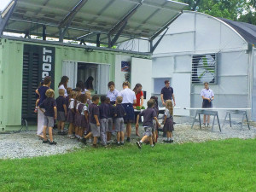
Kohlie will present hydroponics on various levels, both globally and locally. His company’s product, the Helical Outpost, is a sustainable, integrated hydroponic greenhouse and power station with satellite Internet access and a water filtration system that creates up to 2,000 gallons of clean water a day, 11 kilowatt hours of commercial grade solar power and 2,300 crop units per week. The Outpost is in action at the school where it was developed in Lafayette, Louisiana. In addition to providing resources for the community, it has turned into an education hub to teach children. Kohlie will discuss the process of growing food hydroponically.
Kohlie Frantzen grew up in Lafayette. He went into finance at LSU and then law school at Loyola in New Orleans. He was a prosecutor in Jefferson Parish at the time Katrina hit. Kohlie attended a six-week course in California that was created to teach transitioning and returning veterans how to farm. It was an organic farming bootcamp that culminated with the development of a business plan to design a hydroponic organic farm that incorporates the shipping container used in delivery as part of the operation. The Helical Outposts are designed to bring food, water and energy to people anywhere in the world. The Outpost’s hydroponic farm uses 80% less water, 90% less land and produces the equivalent of as much as 3 acres of organic farm soil in as little as 5,000 square feet.

